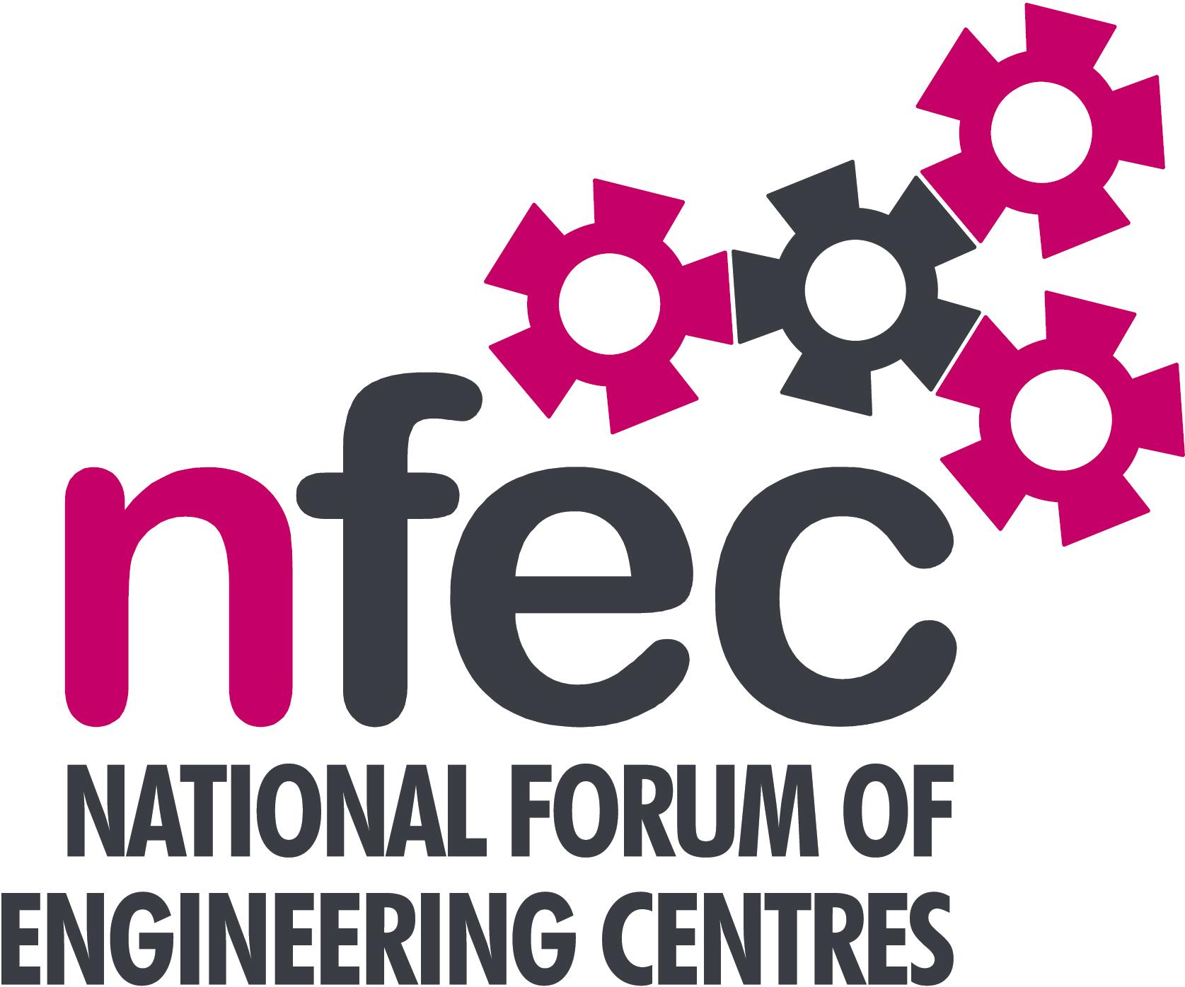
NFEC Spring 2017 South West Regional Seminar

Host: Weston College

Friday 5th May 2017, 10.15am – 15.00 (Coffee from 10.00am)
Venue: South West Skills Campus, Locking Road, Weston Super Mare BS22 8NL
Telephone Number: 01934 411411

Programme

- Welcome and Introduction to the Seminar | Chris Miller (NFEC South West Regional Coordinator) and City of Plymouth College  Ross Hawkins, Steve Caldwell – Weston College | 10.15
- Current matters of concern relating to quality, content, structure, management and delivery of programmes of training and education in Engineering (not included on Agenda) - an opportunity for open discussion with a focus to distill key issues and plans for addressing them.  - Levy funding  - Update on Welding Trailblazer developments  - GKN Aerospace Apprentices on a Trailblazer programme give feedback on their experience  Lunch and Demonstrations by Exhibitors  - Qualifications and Awarding Bodies – Current developments and general issues.  Tour of facilities  - Plenary session – Issues to note and agreed actions for NFEC  - Date, Place and Topics for next Seminar  Close  Entry is free to this seminar for members or to non-members present for a first attendance.There will be a charge for non members after this. A light buffet lunch will be provided and you will be able to see/discuss demonstrations of the latest available equipment and facilities for the delivery of learning in Engineering. | All Delegates/Chris Miller  Liz Redwood, Executive Director for Business Growth, Weston College  Hugh McPhillips, GETS training  GKN Aerospace apprentices  EAL – Bill Lockyer  Pearson – Bridget Stait, Steve Smith  C&G – Simon Yorke  AQA – Dean O’Donoghue  OCR – Martin Webber  All Delegates/Chris Miller  To book your place: Email: admin@nfec.org.uk  Phone: 07759 901229 | 10.20  10.45  11.15  11.45  12.15  13.00  14.00  14.45

